

**APPLIED PHYSICS LAB**

**Lab Report: Calibrating the Thermo-Couple by Deﬂection Method**

**Submitted To:**

Sir. Haseen Ullah Jan

**Submitted By:**

Ali Asghar

Section C

Registration No. 21PWCSE2059

Department Of Computer Systems Engineering

Fall 2021

**THERMO-COUPLE**

A Thermocoupleis a sensor used to measure temperature. Thermocouplesconsist of two wire legs made from different metals. The wires legs are welded together at one end, creating a junction. This junction is where the temperature is measured. When the junction experiences a change in temperature, a voltage is created.

A thermocouple can be any junction between two different metals and may be used to measure temperature. Each metal produces a different electrical potential that varies according to changes in temperature. This rate of change is different for each of the metals in the thermocouple, so a thermocouple produces a voltage that increases with temperature.

**APPARATUS:**

The following apparatus is used to carry out this calibration experiment:

1. 2 thermometers
2. 2 Beakers
3. 2 Test Tubes
4. Galvanometer
5. Spirit Lamp
6. Stand
7. Water
8. Wire
9. Heater Rod

**PROCEDURE:**

Following procedure is followed to carry out this experiment:

1. 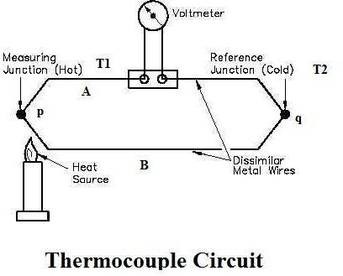Test tubes are both completely ﬁlled with mercury.
2. Test tubes are dipped with eurika and copper wires respectively and joined by ends.
3. These joined wires are now became thermocouples.
4. These test tubes are dropped into two beakers where a heating rod is also dipped in one of the beakers.
5. As the temperature is increased gradually, it gives the voltmeter gives

us gradual readings to correspondent temperature respectively.

1. We also ﬁnd readings mathematically by checking on the temperature difference.
2. At last graph is plotted between △T and V. We will obtain a straight line. 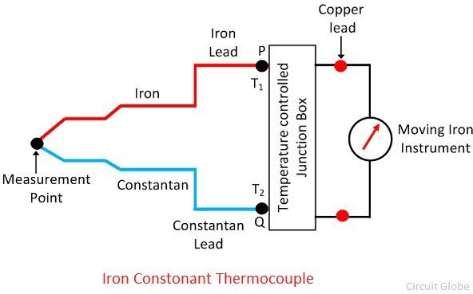

**READINGS:**

|  |  |  |  |
| --- | --- | --- | --- |
| Hot Side Temperature | Cold side Temperature | Voltage in Volts | △T=T2-T1 |
| 25 ० C | 20० C | 0.1 V | 5 ०C |
| 35० C | 20० C | 0.2 V | 15 ०C |
| 45० C | 20० C | 0.3 V | 25 ०C |
| 55० C | 20० C | 0.4 V | 35 ०C |
| 65० C | 20० C | 0.5 V | 45 ०C |
| 75० C | 20० C | 0.6 V | 55 ०C |

**PRECAUTIONS:**

1. Check apparatus for error.
2. Stay away from hot water or hot rod.
3. Don’t touch eureka wire.